**Assignment -1**

SMART HOME AUTOMATION

|  |  |
| --- | --- |
| Assignment Date | 22 September 2022 |
| Student Name | S.Vijaya Kumar |
| Student Roll Number | 950619106305 |

**Question-1:**

Create a smart home automation using Tinkercad .(Using atleast 2 sensors and LED, buzzer)

**Link :**

https://www.tinkercad.com/things/bu4FBF4KSwp

**Program :**

int pinSensor =2;

int pinLed =12;

int pinBuzzer =13;

int pirSensor =0;

int led =13;

int sensor = 2;

int state = LOW;

int val = 0;

void setup(){

{

pinMode(led,OUTPUT);

pinMode(sensor,INPUT);

Serial.begin(9600);

}

{

pinMode(pinSensor, INPUT);

pinMode(pinLed, OUTPUT);

pinMode(pinBuzzer, OUTPUT);

}

}

void loop(){

int analogvalue = analogRead(A0);

Serial.print("analogvalue:");

Serial.println(analogvalue);

val=digitalRead(sensor);

if(val==HIGH){

digitalWrite(led,HIGH);

}

delay(500);

if(state==LOW){

Serial.println("Motion detected!");

state=HIGH;

}

else{

digitalWrite(led,LOW);

delay(500);

}

If(state==HIGH){

Serial.println("Motion stopped");

state=LOW;

pirSensor = digitalRead(pinSensor);

}

if (pirSensor == HIGH)

{

digitalWrite(pinLed, HIGH);

tone(pinBuzzer, 1000, 500);

}

else {

digitalWrite(pinLed, LOW);

}

delay(10);

}

**Circuit Design :**

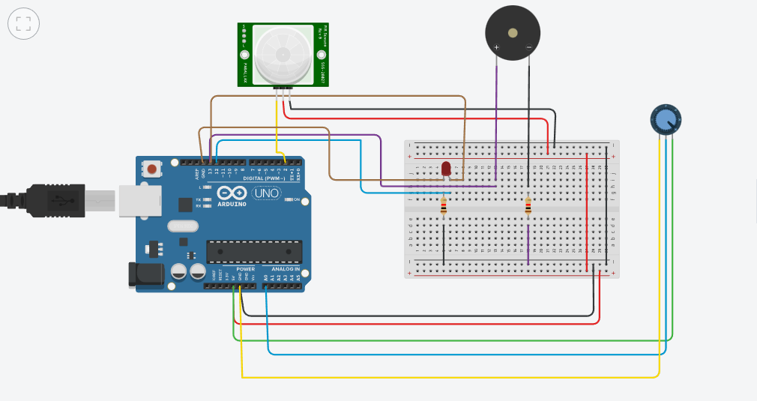

**Output :**

